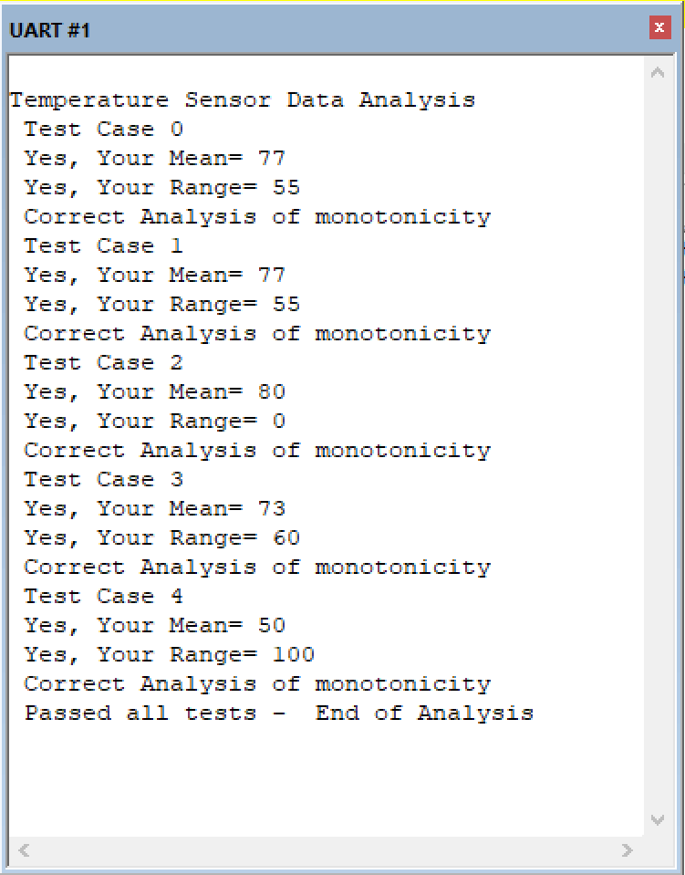

// ****************** Lab2.c ***************

// Program written by: Ali Mansoorshahi

// Date Created: 2/6/2017

// Last Modified: 2/6/2018

// Brief description of the Lab;

// This version is for the combined EE319K (Valvano) EE312 (Gligoric) sections

// An embedded system is capturing temperature data from a

// sensor and performing analysis on the captured data.

// The controller part of the system is periodically capturing size

// readings of the temperature sensor. Your task is to write three

// analysis routines to help the controller perform its function

// The three analysis subroutines are:

// 1. Calculate the mean of the temperature readings

// rounded down to the nearest integer

// 2. Calculate the range of the temperature readings,

// defined as the difference between the largest and smallest reading

// 3. Check if the captured readings are a non-increasing montonic series

// This simply means that the readings are sorted in non-increasing order.

// We do not say "increasing" because it is possible for consecutive values

// to be the same, hence the term "non-increasing". The controller performs

// some remedial operation and the desired effect of the operation is to

// lower the the temperature of the sensed system. This routine helps

// verify whether this has indeed happened

#include "Lab2.h"

#define True 1

#define False 0

// Return the computed Mean

// Readings is an array of length N

// N is the length of the array

uint8_t Find_Mean(uint8_t Readings[],uint32_t N){

// Replace ths following line with your solution

int32_t sum = 0;

for(int i = 0; i < N; i++)

{

sum += Readings[i];

}

return(sum / N);

}

// Return the computed Range

// Readings is an array of length N

// N is the length of the array

uint8_t Find_Range(uint8_t Readings[],uint32_t N){

// Replace ths following line with your solution

int32_t max = -200000000;

int32_t min = 200000000;

for(int i = 0; i < N; i++)

{

if(Readings[i] > max)

{

max = Readings[i];

}

if(Readings[i] < min)

{

min = Readings[i];

}

}

return(max - min);

}

// Return True of False based on whether the readings

// a non-increasing montonic series

// Readings is an array of length N

// N is the length of the array

uint8_t IsMonotonic(uint8_t Readings[],uint32_t N){

// Replace ths following line with your solution

for(int i = 0; i< N-1; i++)

{

if(Readings[i] < Readings[i+1])

{

return False;

}

}

return True;

}

//Testcase 0:

// Scores[N] = {80,75,73,72,90,95,65,54,89,45,60,75,72,78,90,94,85,100,54,98,75};

// Range=55 Mean=77 IsMonotonic=False

//Testcase 1:

// Scores[N] = {100,98,95,94,90,90,89,85,80,78,75,75,75,73,72,72,65,60,54,54,45};

// Range=55 Mean=77 IsMonotonic=True

//Testcase 2:

// Scores[N] = {80,80,80,80,80,80,80,80,80,80,80,80,80,80,80,80,80,80,80,80,80};

// Mean=80 Range=0 IsMonotonic=True

//Testcase 3:

// Scores[N] = {100,80,40,100,80,40,100,80,40,100,80,40,100,80,40,100,80,40,100,80,40};

// Mean=73 Range=60 IsMonotonic=False

//Testcase 4:

// Scores[N] = {100,95,90,85,80,75,70,65,60,55,50,45,40,35,30,25,20,15,10,5,0};

// Range=100 Mean=50 IsMonotonic=True